**Topic-1: Volumes**

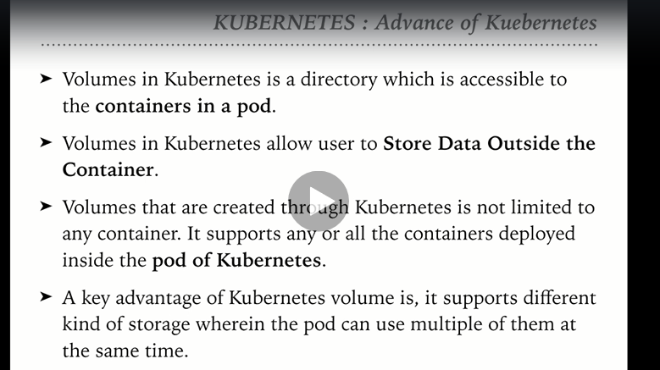

**There are 12 types of volumes in Kubernetes:**

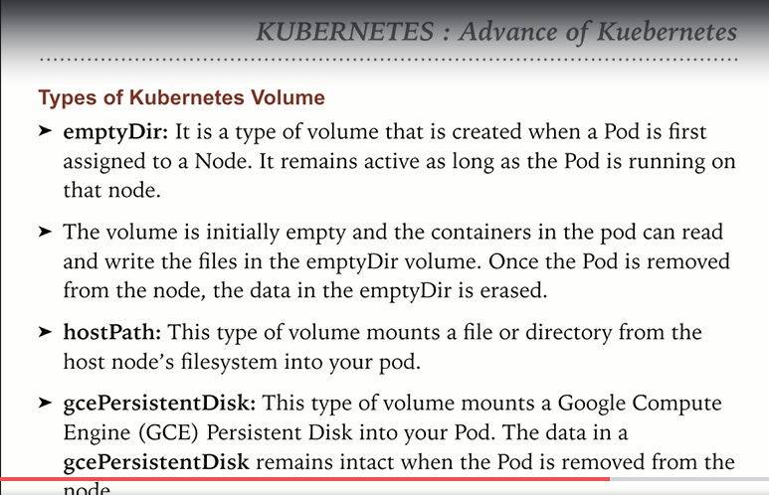

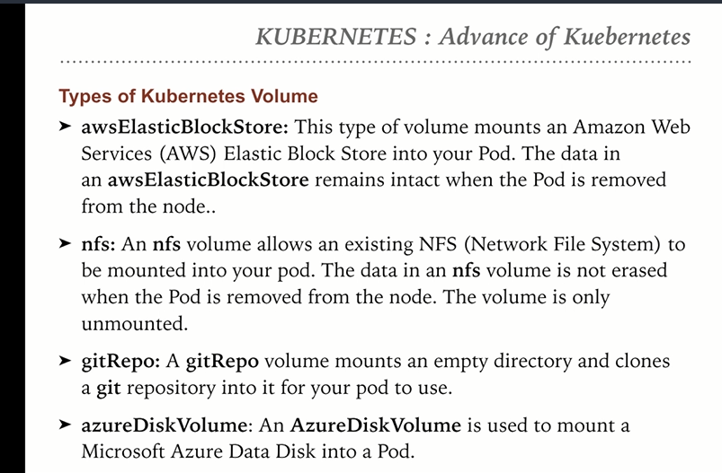

**How to define a emptyDir Volume:**

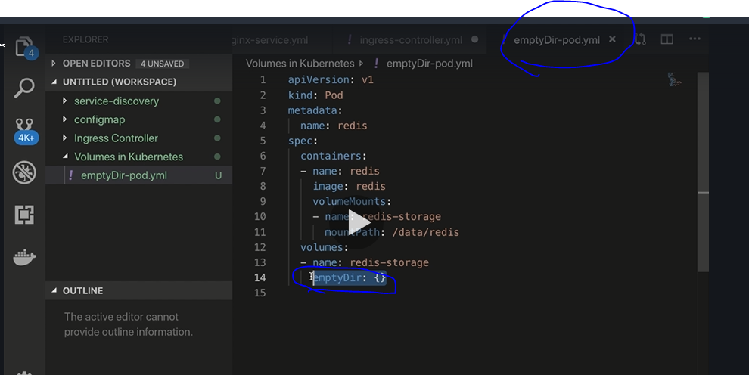

**Create a pod with the above manifest file.**

**Access the pod using exec mode and verify the mount path specified in the emptyDir-pod.yml**

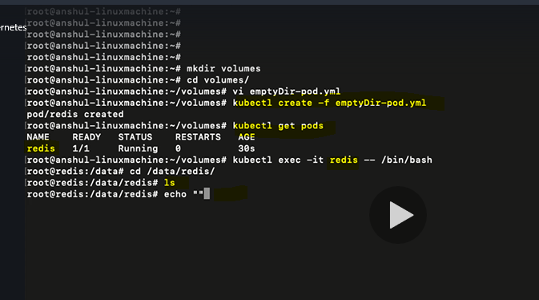

**Create a new file in the same mount path**

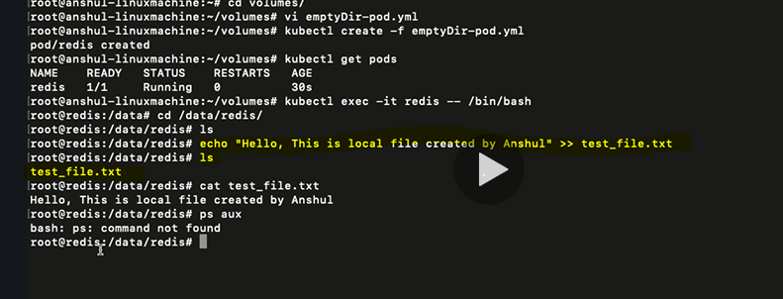

**Install ps aux**

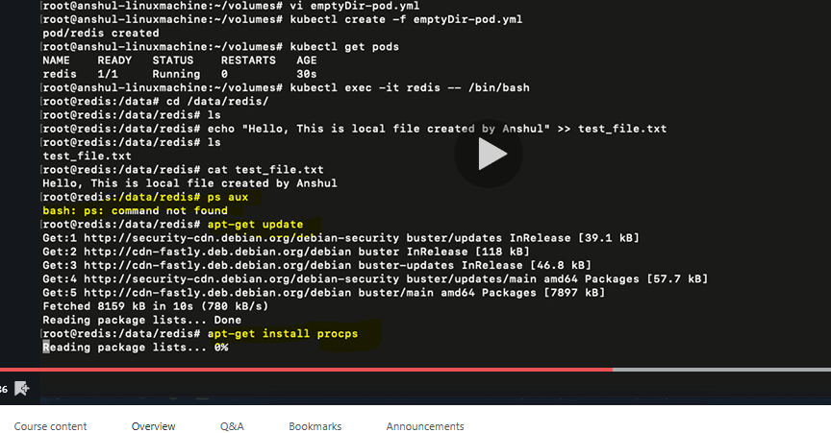

**Verify the process which are running**

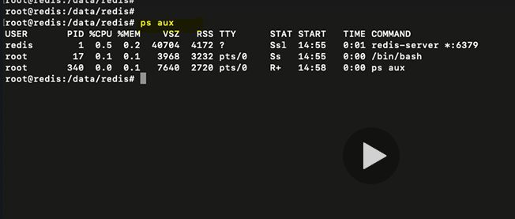

**Kill the process with PID =1 which is basically redis and observe the pod status using watch**

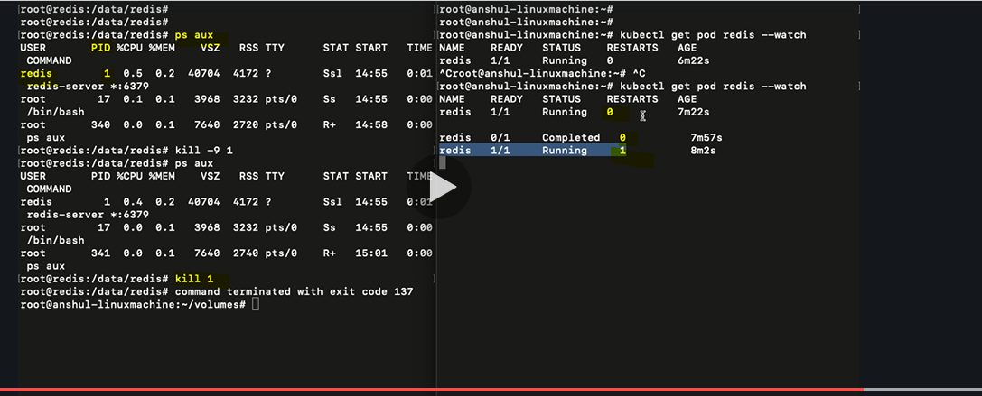

**In the below screenshot observe that the file which we had created in the mount path still exists even though the process was restarted**

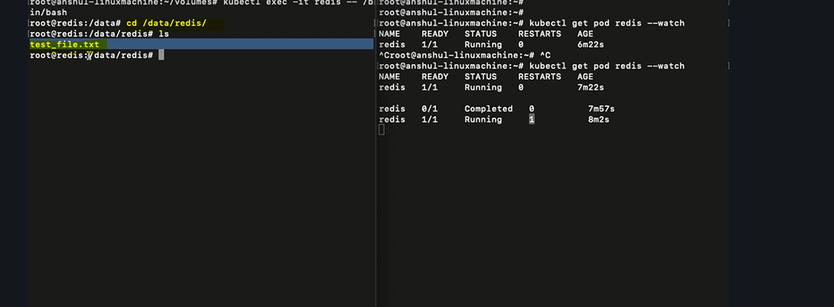

**But if we remove the pod then the mount path will be deleted because the pod no longer exists**

**Topic-3: Host Path**

**Start the minikube service**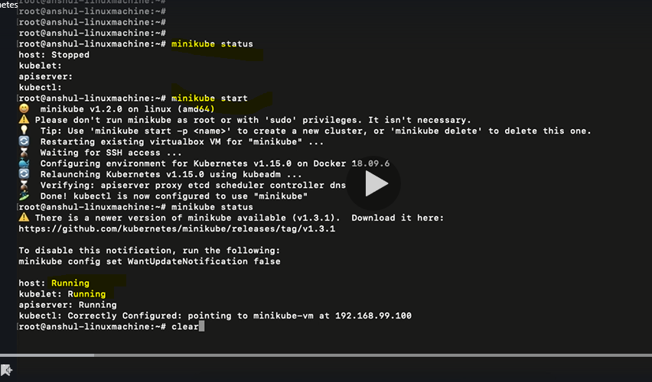

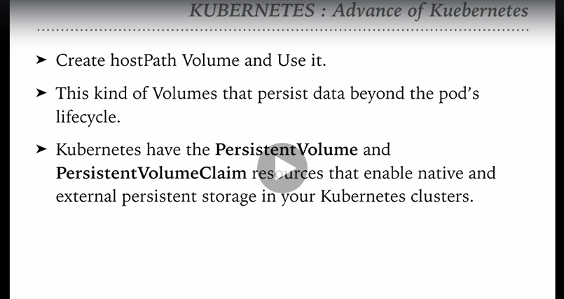

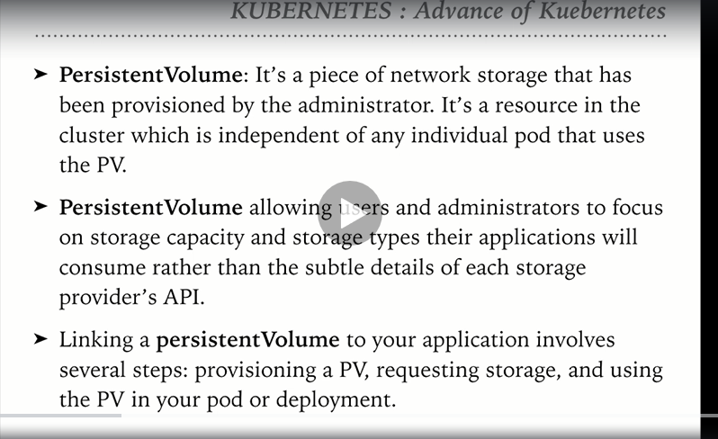

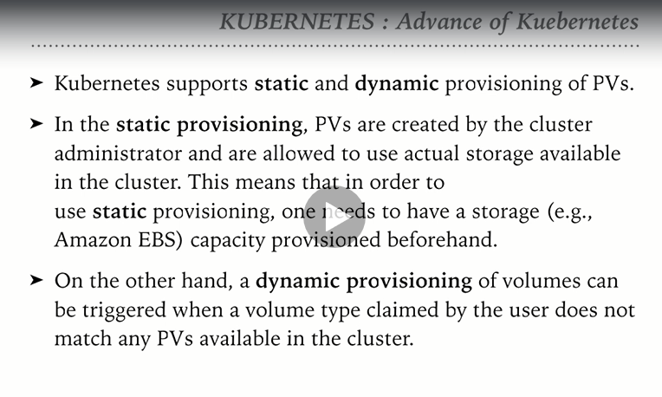

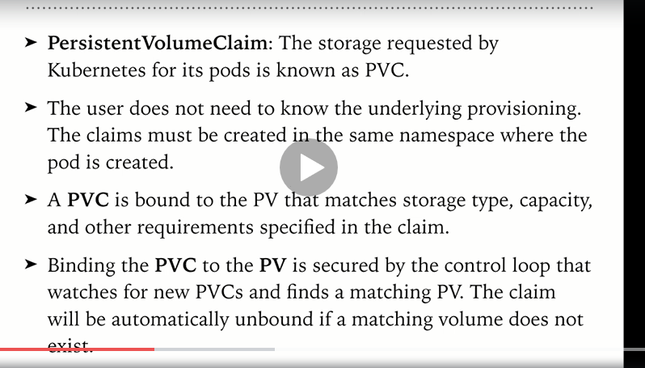

**As we know that the Volumes can be mounted from the host machine where Kubernetes is running, we need to ssh to minikube. In our example we are using mimikube for running the cluster. So, the mount path should be inside the minikube vm rather than our local linux machine.**

**That is the reason we are trying to ssh to minikube.**

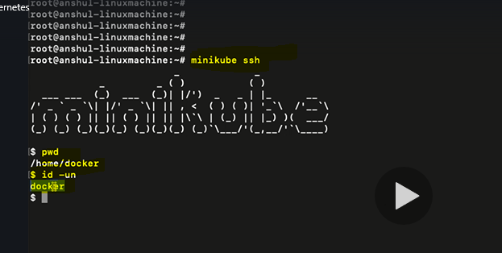

**Create a directory inside minikube and create a file with some content as shown below:**

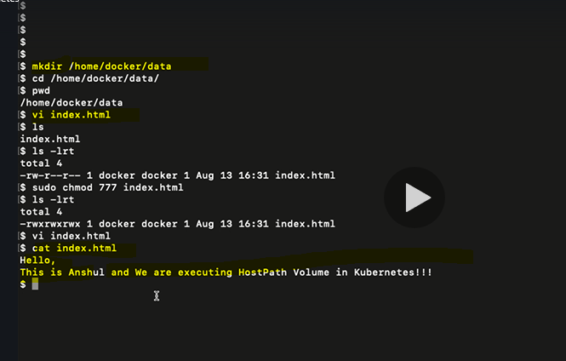

**Exit from Minikube**

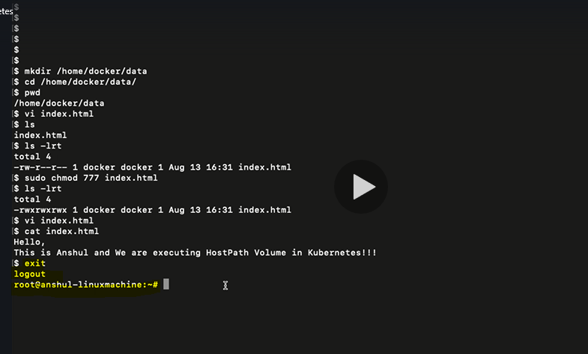

**Create a persistent data file**

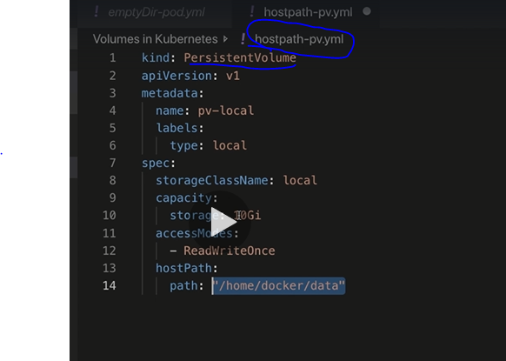

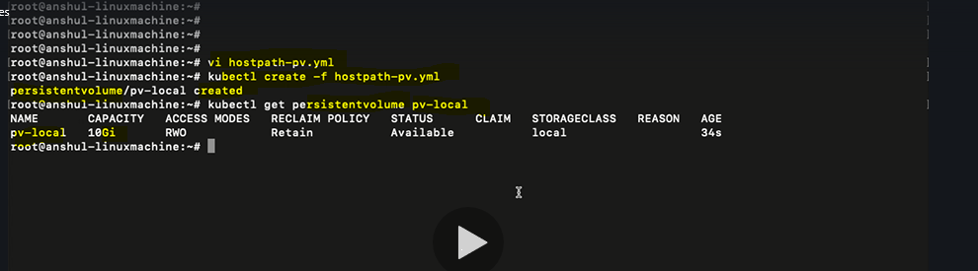

**Create a persistentVolumeclaim file for the PersistentVolume**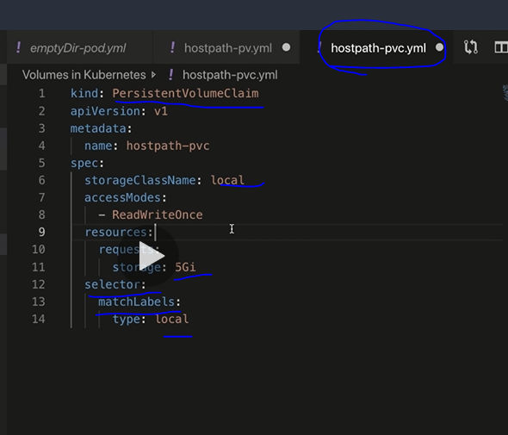

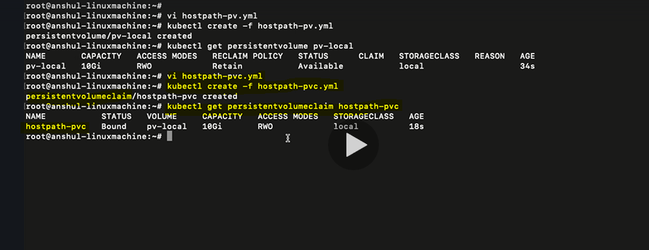

**Create a deployment file which references the persistentVolumeClaim**

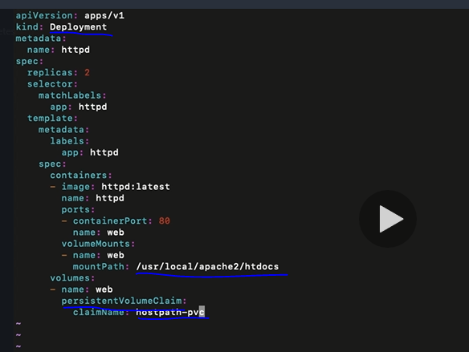

**Create deployment, expose the service and get the service url**

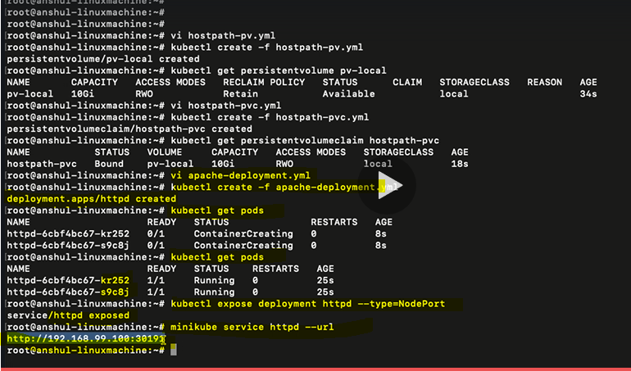

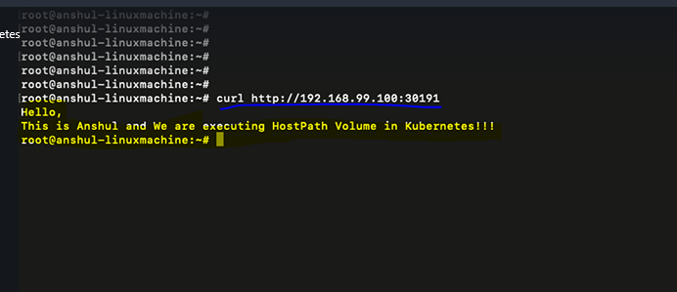

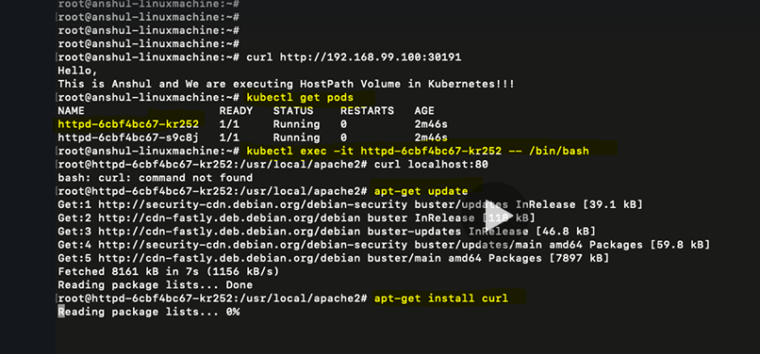

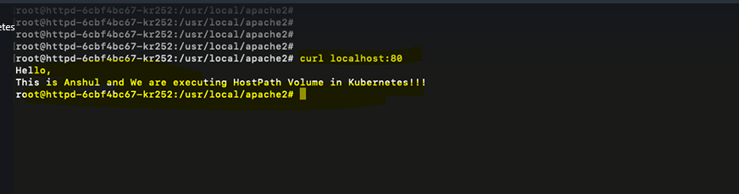

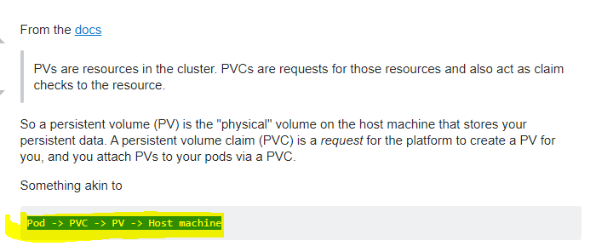

**Topic-4: Dynamic Volume provisioning in Kubernetes**

**emptyDir and hostpath are static volumes. In this topic let us learn about Dynamic volume provisioning**

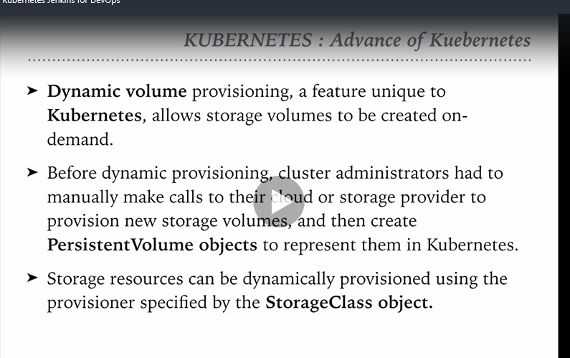

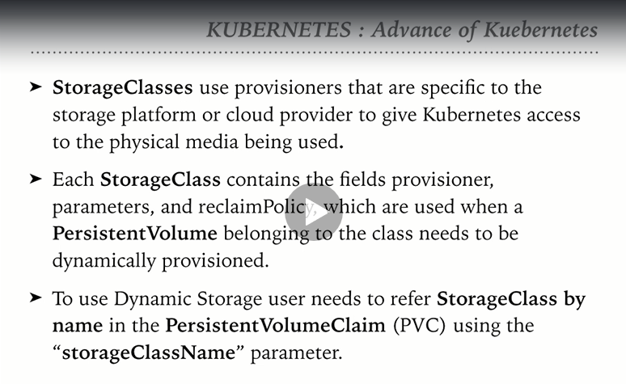

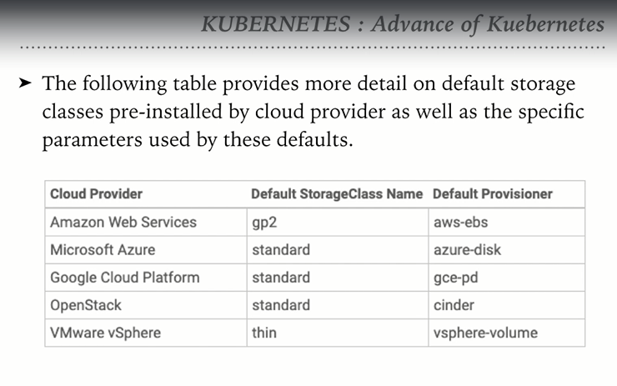

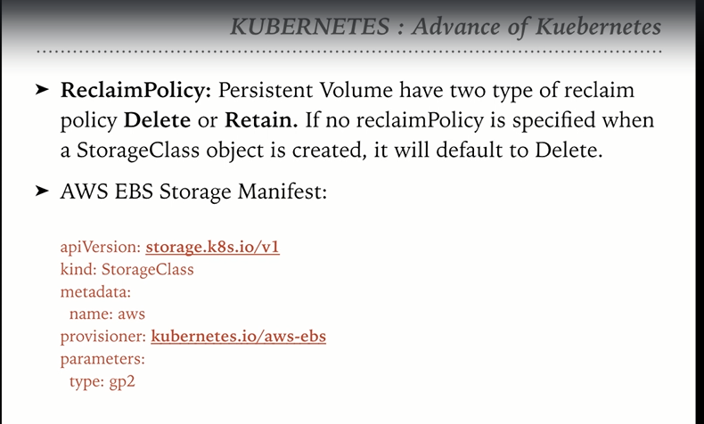

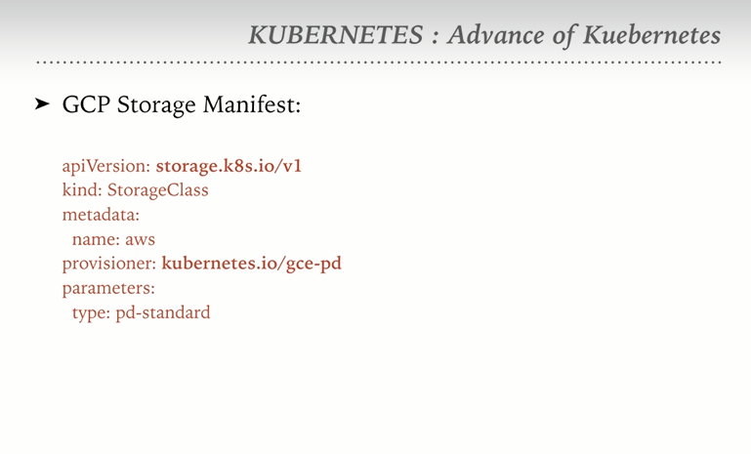

**Topic-5:Dynamic volume provisioning in detail**

**Stop the minikube service as we are going to start the Kubernetes service on AWS**

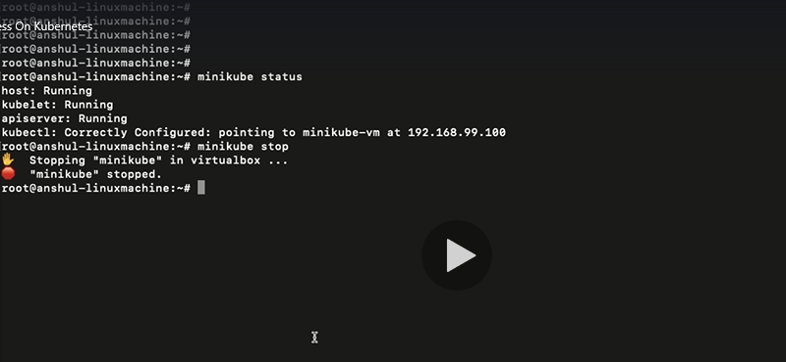

**Create a Kubernetes cluster on AWS by following the below highlighted commands:**

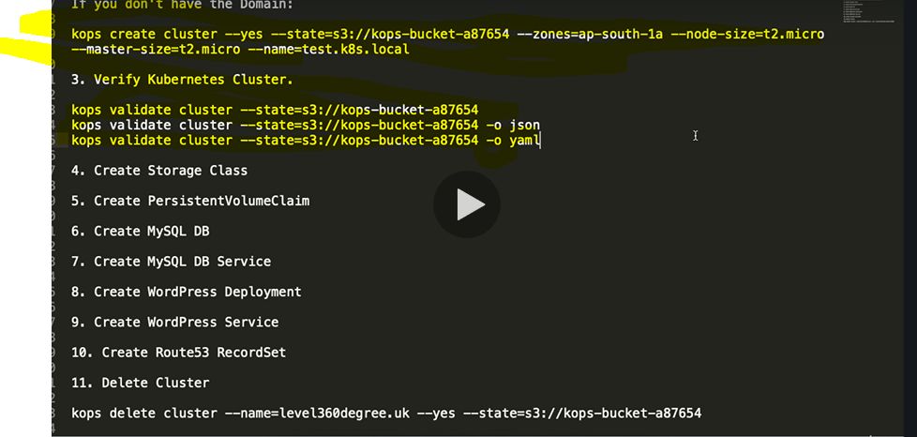

**Create a storage class yaml file. Please make sure that the zone should be same as that of the zone used while creating the cluster. Provisioner as aws-ebs**

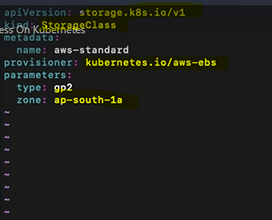

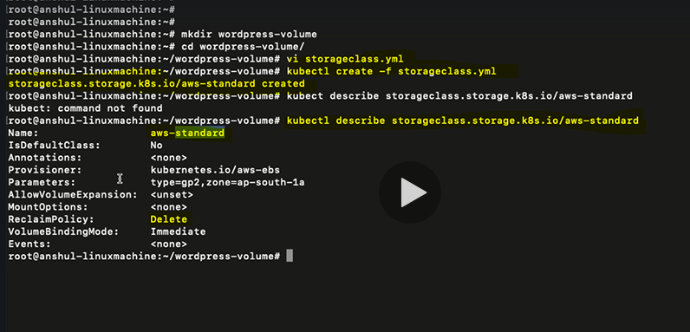

**If you want to change the reclaim policy then update in the storage class manifest**

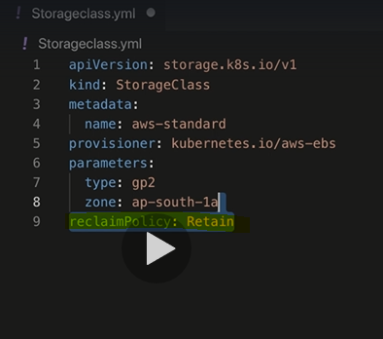

**Create a persistentvolumeclaim:**

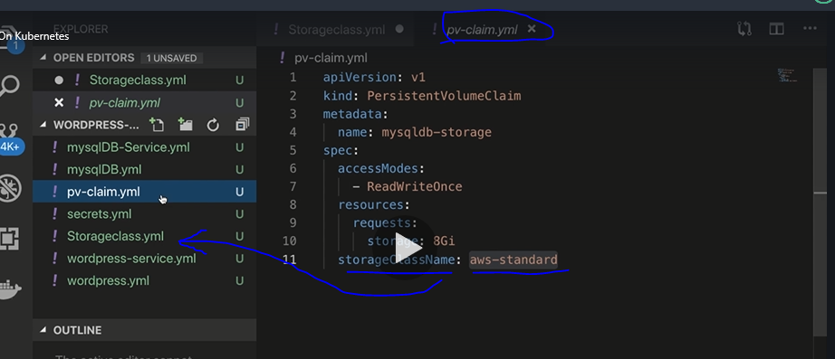

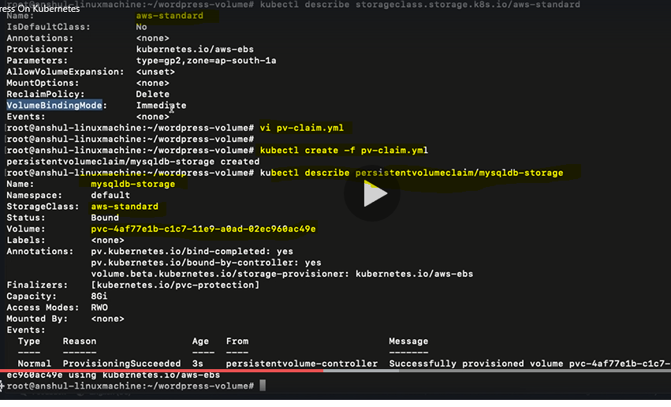

**Verify in AWS if there is a volume created**

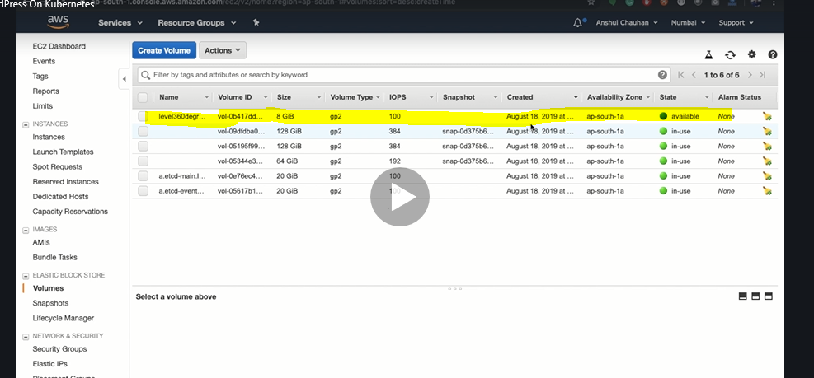

**Here we need to understand that the above volume is created dynamically when we created the persistentVolumeclaim. Before that it was not created with the storage class**

**Create secrets:**

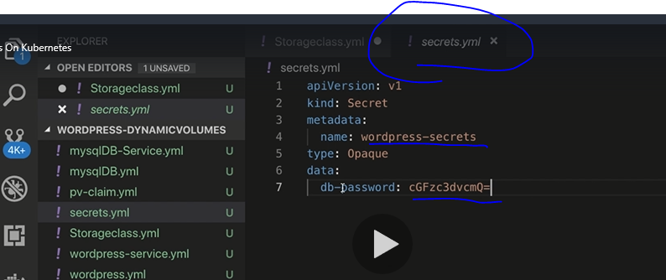

**Create a replication controller manifest and observe the highlighted fields, they reference to the secreste and PVC which are already created:**

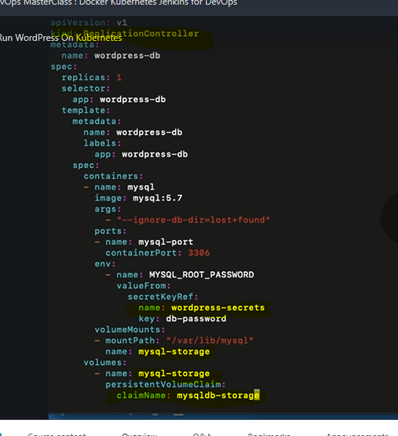

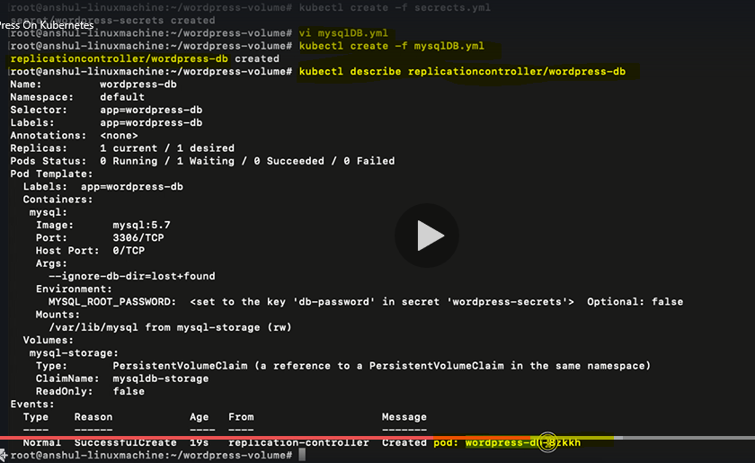

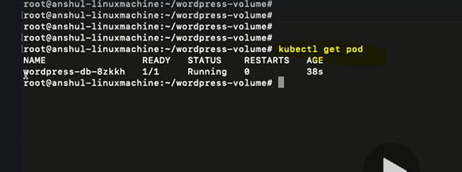

**Create a service for the deployment created in the previous step**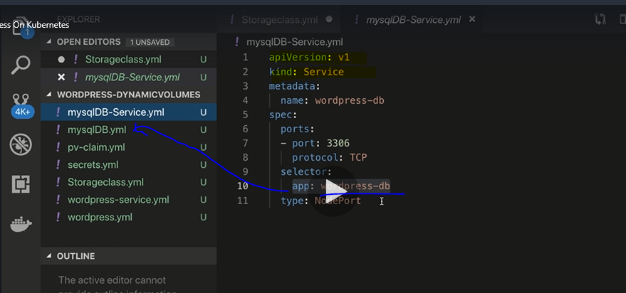

**Create the service**

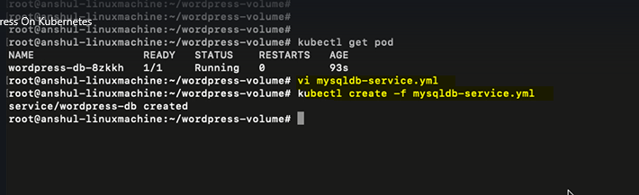

**Create a manifest file for wordpress**

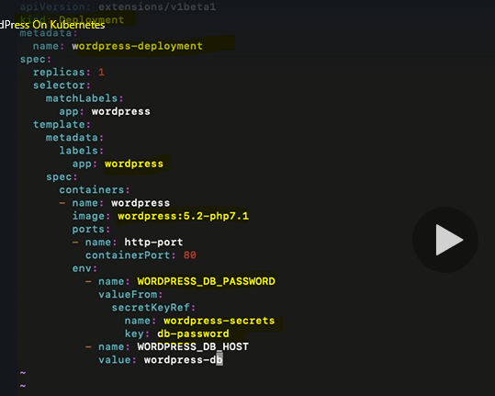

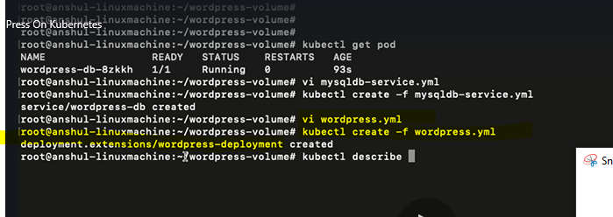

**Create a service for wordpress. Observe the type: Loadbalancer.**

Cre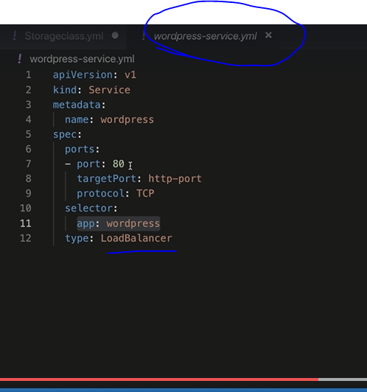

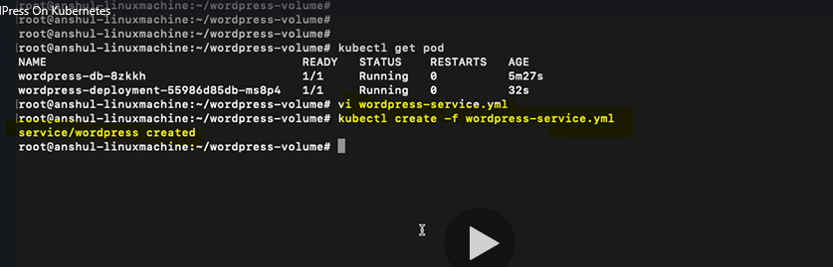

**Go to AWS and verify if the loadbalancer is created:**

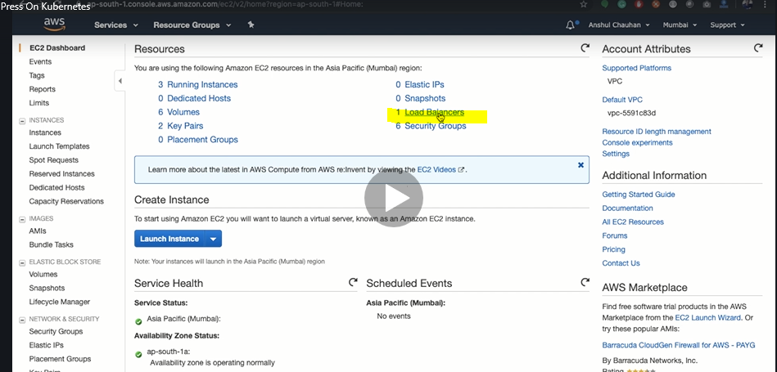

**If you are not using any domain then we can use the DNS name of the load balanacer to access the service:**

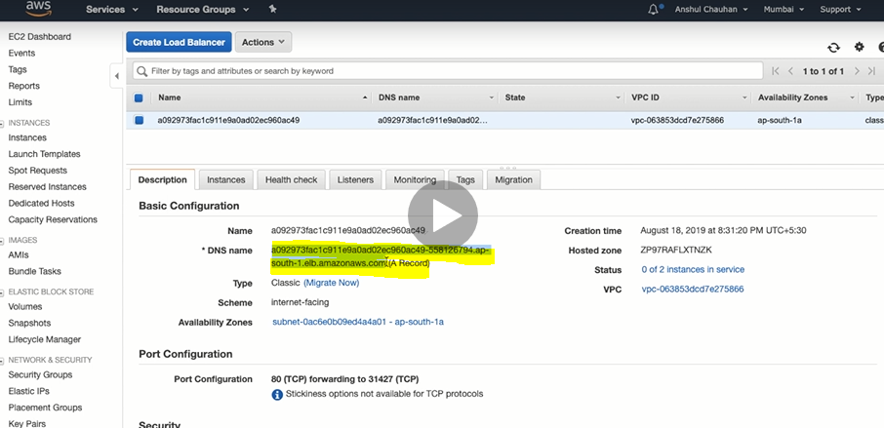

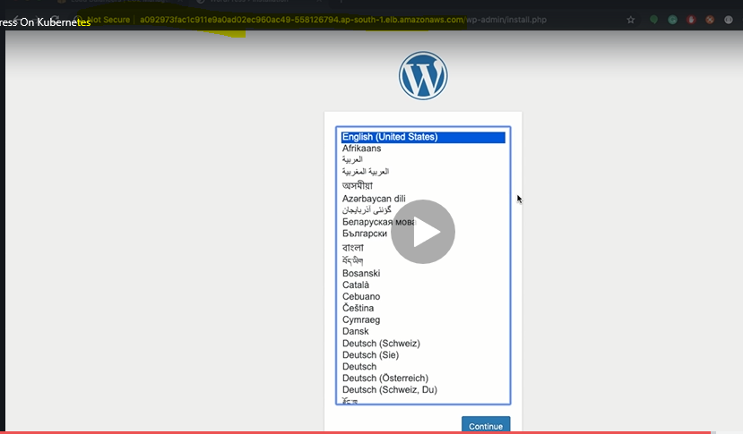

**If we are using any domain then go to Route S3 services>Hosted Zones**

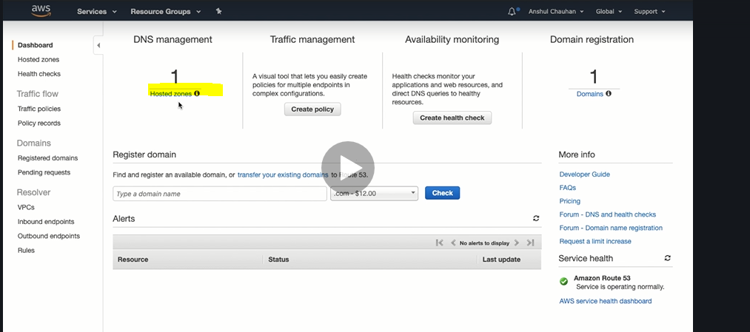

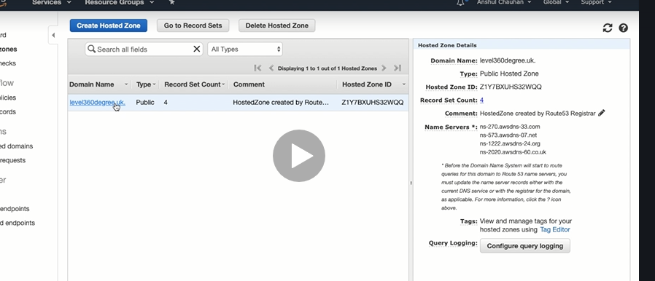

**Click on “Create Record Set”:**

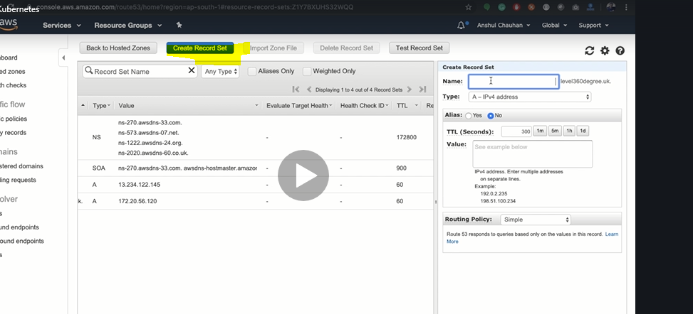

**Define a name and select LoadBalancer from AliasTargetas shown below:**

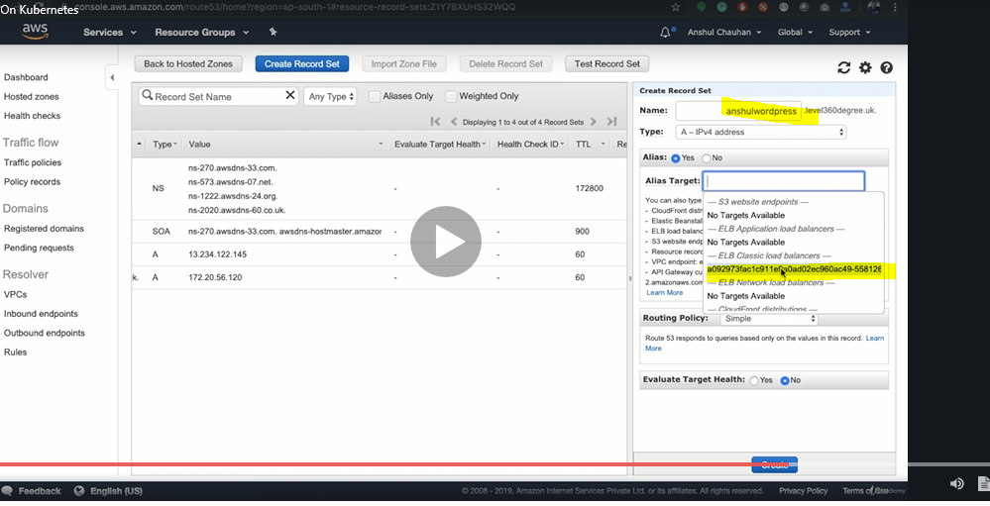

**A new record is created as highlighted below:**

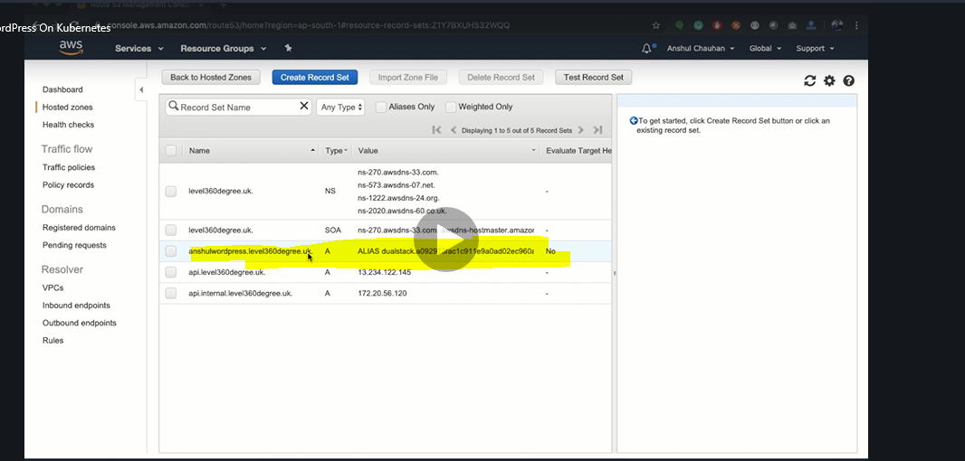

**Open the browser and type the url**

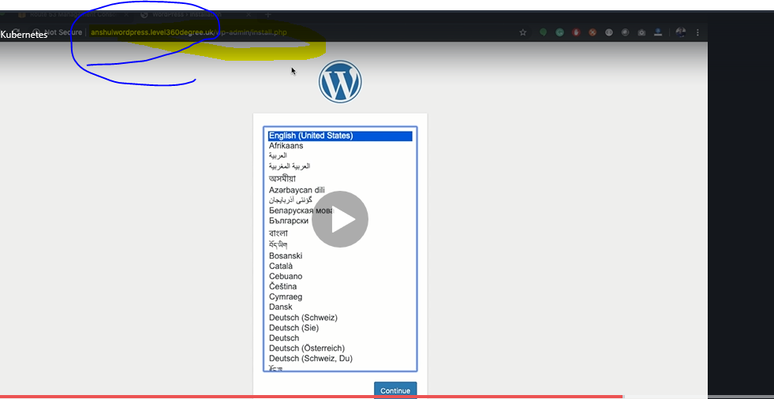

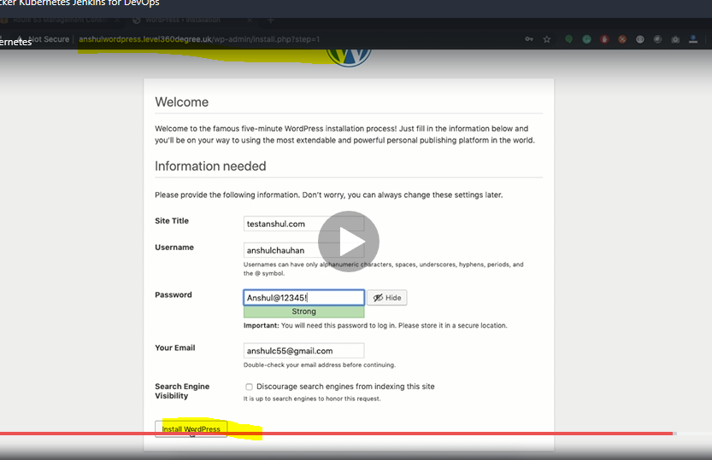

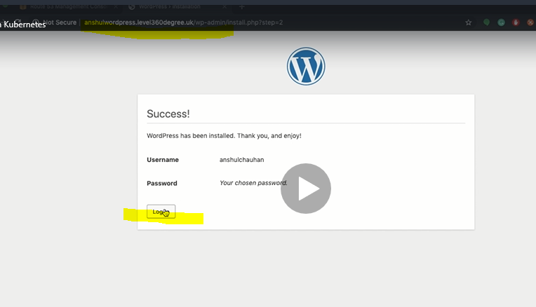

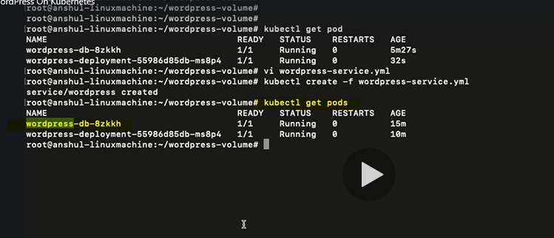

**Delete the database pod and try to access the url**

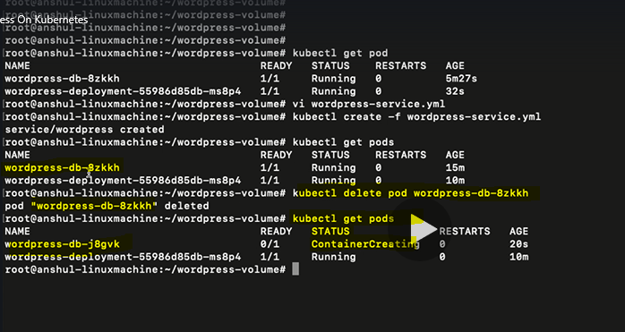

**From the above screenshot we can observe that the new pod(container) is created**

**Refresh the url once the pod status is Running**

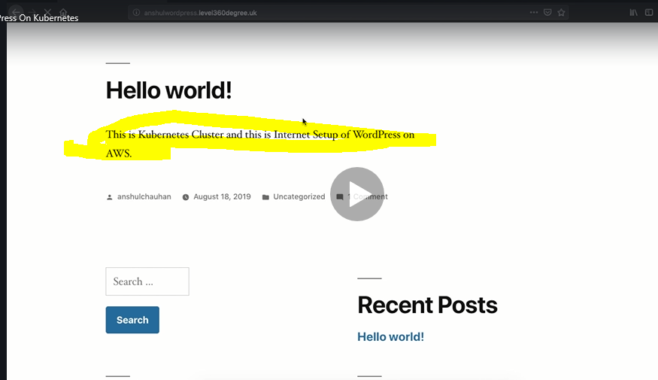

**Notice that the content is not changed even though we have deleted the db. This is because we are using the persistentVolume and the data is mounted on the aws and not on the container.**

**Delete Kops cluster just to free up the services which were in use:**

